Ex.No:8 | Mini Project – Social Media Data Analytics
Aim:
Social Media Data Analytics using Python, Pandas, Matplotlib, and Exploratory Data Analysis
Algorithm:
Algorithm – Platform Statistics Data Analysis
Step 1: Start the Program
- Start the Python program.
- Import the required libraries such as Pandas, NumPy, Matplotlib, and Seaborn.
Step 2: Load the Dataset
- Read platform_statistics_2026
- Store the data in a DataFrame named df.
Step 3: Create a Working DataFrame
- Create a copy of df.
- Store the copy in platform.
- This allows the original dataset to remain unchanged.
Step 4: Inspect the Dataset
- Display the first few records using head().
- Display the last few records using tail().
- Check the number of rows and columns using shape.
- Display column names and data types.
Step 5: Clean the Data
- Check missing values using isna().sum().
- Identify duplicate records using duplicated().
- Remove duplicate records using drop_duplicates().
- Standardize column names into lowercase and underscore format.
Step 6: Perform Statistical Analysis
- Use describe() to calculate statistical values.
- Find mean, minimum, maximum, and standard deviation.
- Analyze numerical platform statistics such as users, growth, time, and engagement.
Step 7: Filter, Sort and Group Data
- Filter records according to required conditions.
- Sort platforms based on important numerical measures.
- Group the data using suitable categorical fields such as age group, content format, or headquarters country.
- Calculate totals and averages for comparison.
Step 8: Create Visualizations
- Create suitable charts using Matplotlib and Seaborn.
- Generate bar charts, line charts, histograms, box plots, scatter plots, and count plots.
- Create a correlation heatmap for numerical variables.
Step 9: Analyze the Results
- Compare platform performance.
- Identify platforms with higher users, growth, engagement, and daily usage.
- Analyze relationships between numerical variables.
- Identify important trends and patterns from the visualizations.
Step 10: Display and Store the Final Results
- Display the cleaned dataset and analysis results.
- Save the cleaned platform dataset if required.
- Use the cleaned data for Power BI/Tableau dashboard development.
- Present the final insights.
- Stop.
Program:
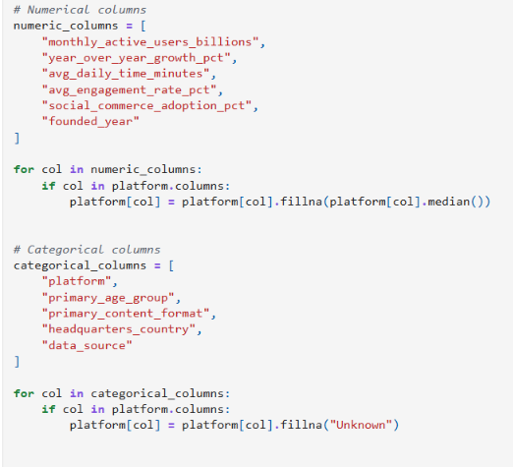
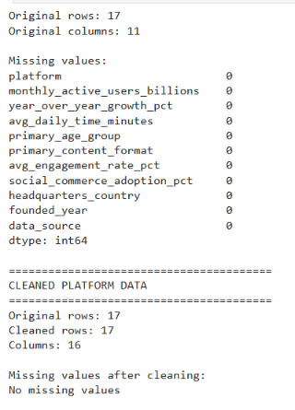
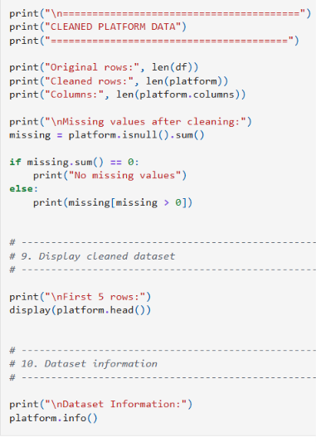
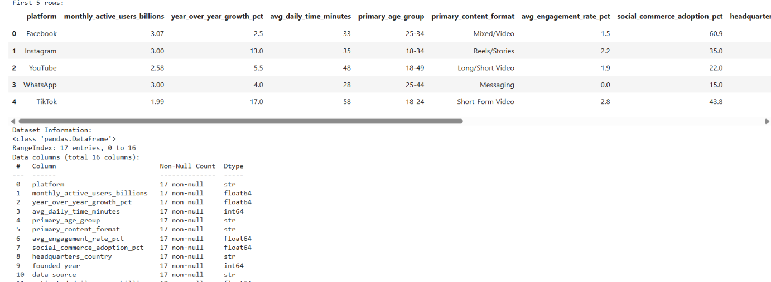
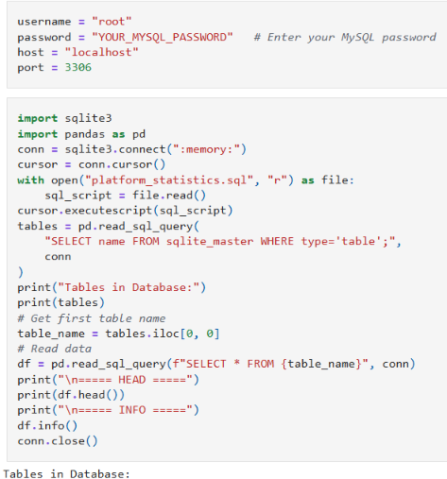
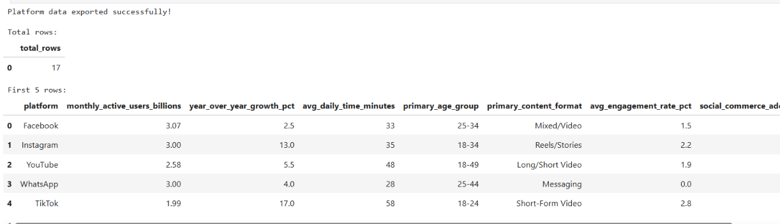
Power bi 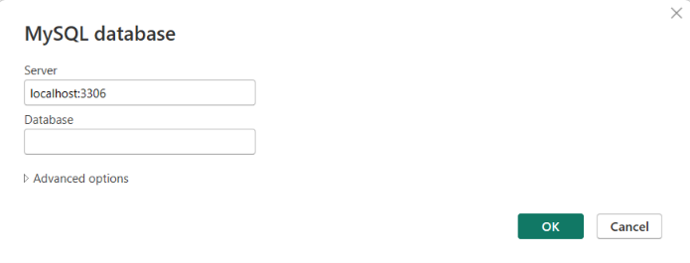
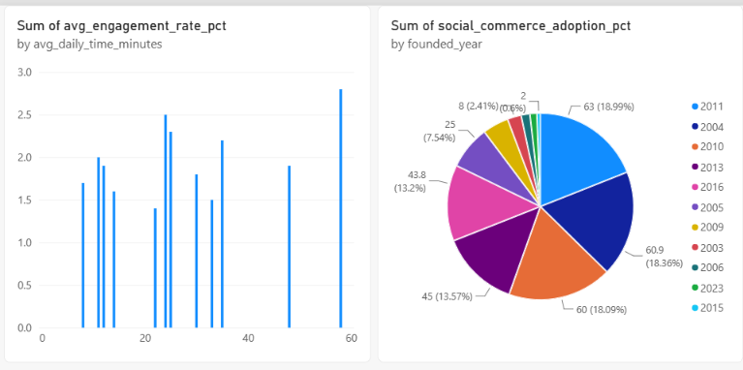
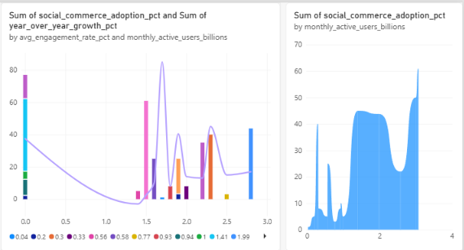

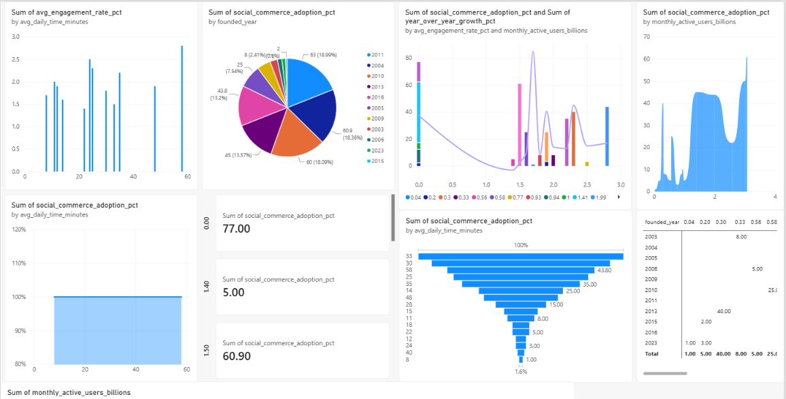

Tabelu
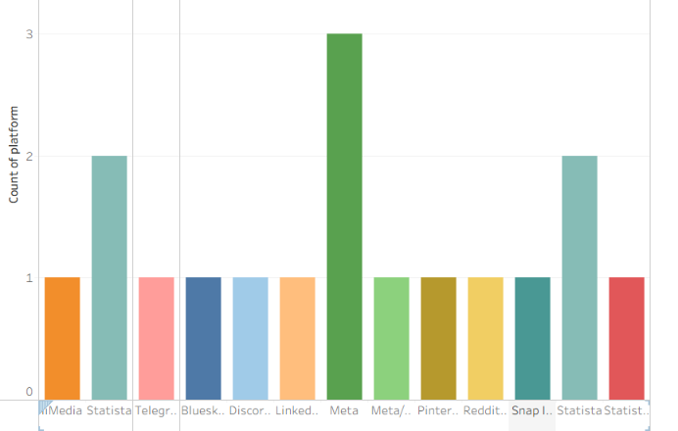
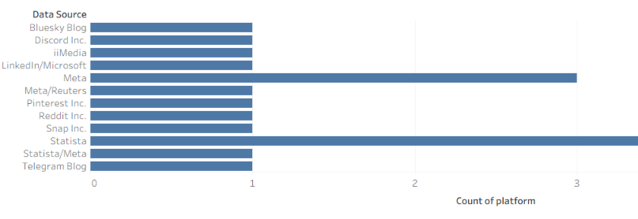
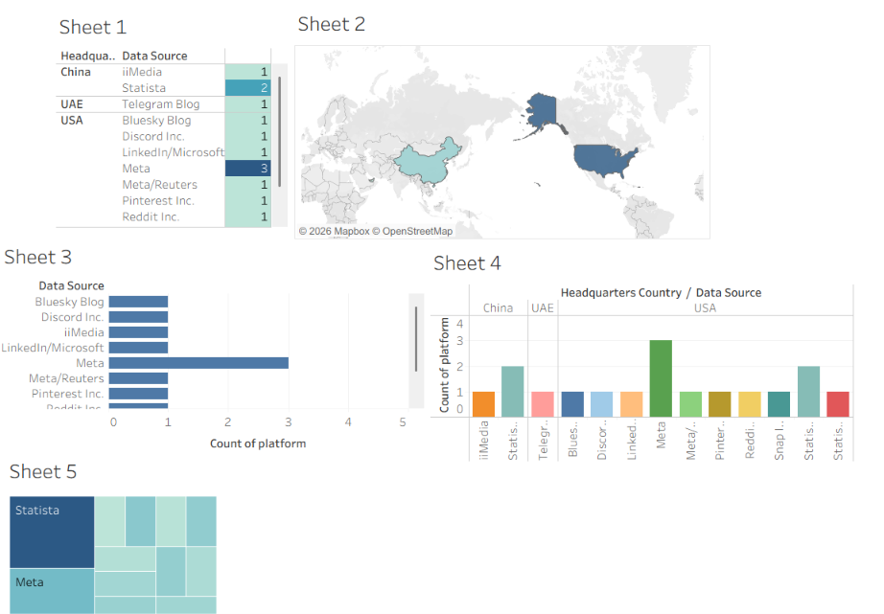

Result:
Thus the data visualization was successfully completed in jupyter,Power BI,Tabelu

Ex.No:9 | Mini Project – Heath care Data Analytics
Aim:
Healthcare Data Analytics using Python, Pandas, Matplotlib, and Exploratory Data Analysis
Algorithm:
Algorithm – Health care Data Analysis
Step 1: Start the Program
- Start the Python program.
- Import the required libraries such as Pandas, NumPy, Matplotlib, and Seaborn.
Step 2: Load the Dataset
- Read health_care
- Store the data in a DataFrame named df.
Step 3: Create a Working DataFrame
- Create a copy of df.
- Store the copy in health.
- This allows the original dataset to remain unchanged.
Step 4: Inspect the Dataset
- Display the first few records using head().
- Display the last few records using tail().
- Check the number of rows and columns using shape.
- Display column names and data types.
Step 5: Clean the Data
- Check missing values using isna().sum().
- Identify duplicate records using duplicated().
- Remove duplicate records using drop_duplicates().
- Standardize column names into lowercase and underscore format.
Step 6: Perform Statistical Analysis
- Use describe() to calculate statistical values.
- Find mean, minimum, maximum, and standard deviation.
- Analyze numerical platform statistics such as users, growth, time, and engagement.
Step 7: Filter, Sort and Group Data
- Filter records according to required conditions.
- Sort platforms based on important numerical measures.
- Group the data using suitable categorical fields such as age group, content format, or headquarters country.
- Calculate totals and averages for comparison.
Step 8: Create Visualizations
- Create suitable charts using Matplotlib and Seaborn.
- Generate bar charts, line charts, histograms, box plots, scatter plots, and count plots.
- Create a correlation heatmap for numerical variables.
Step 9: Analyze the Results
- Compare platform performance.
- Identify platforms with higher users, growth, engagement, and daily usage.
- Analyze relationships between numerical variables.
- Identify important trends and patterns from the visualizations.
Step 10: Display and Store the Final Results
- Display the cleaned dataset and analysis results.
- Save the cleaned platform dataset if required.
- Use the cleaned data for Power BI/Tableau dashboard development.
- Present the final insights.
- Stop.
Program:
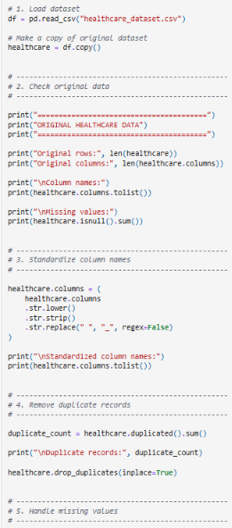
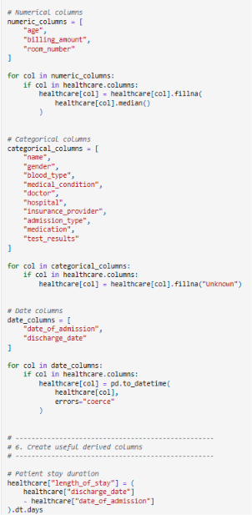
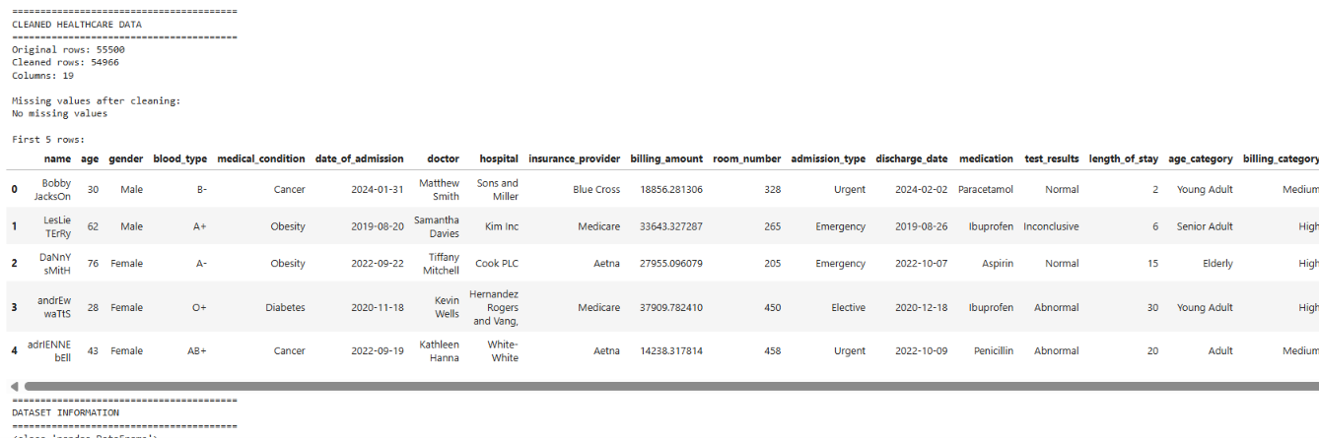

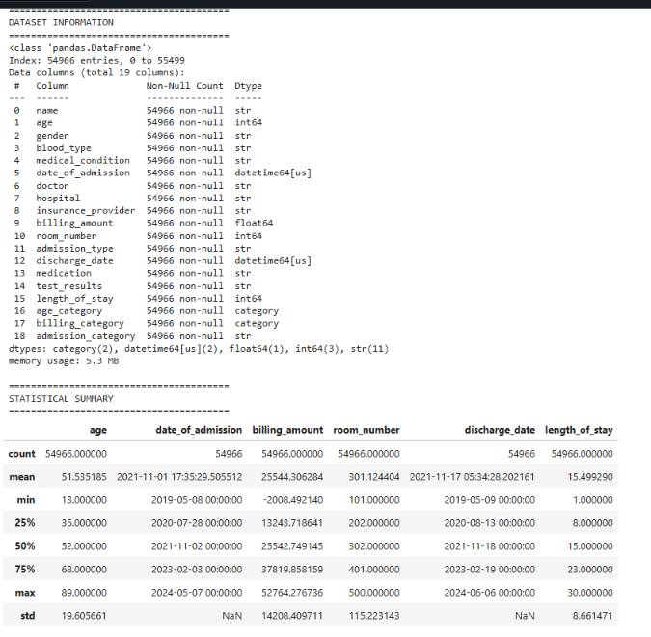
Power Bi:
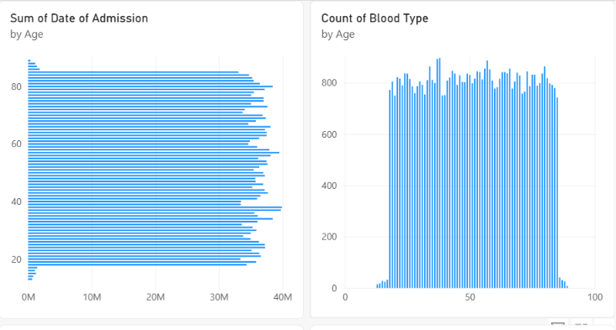
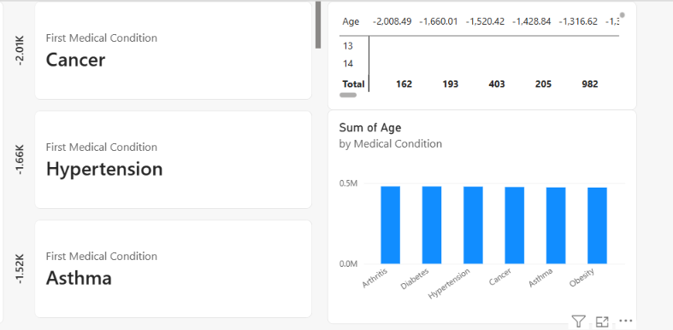
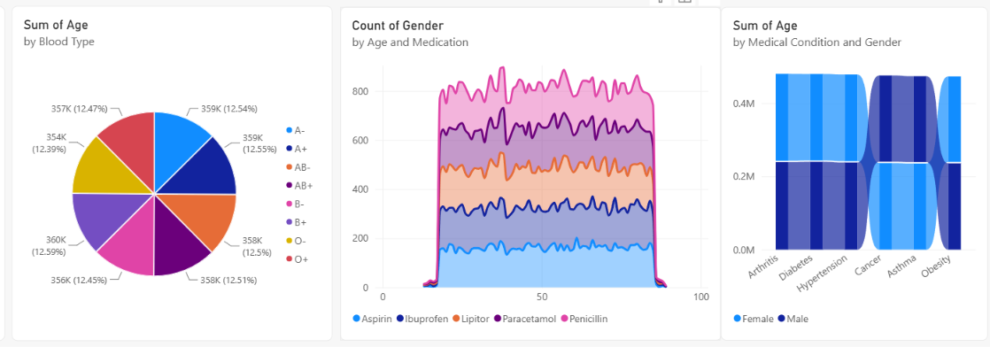

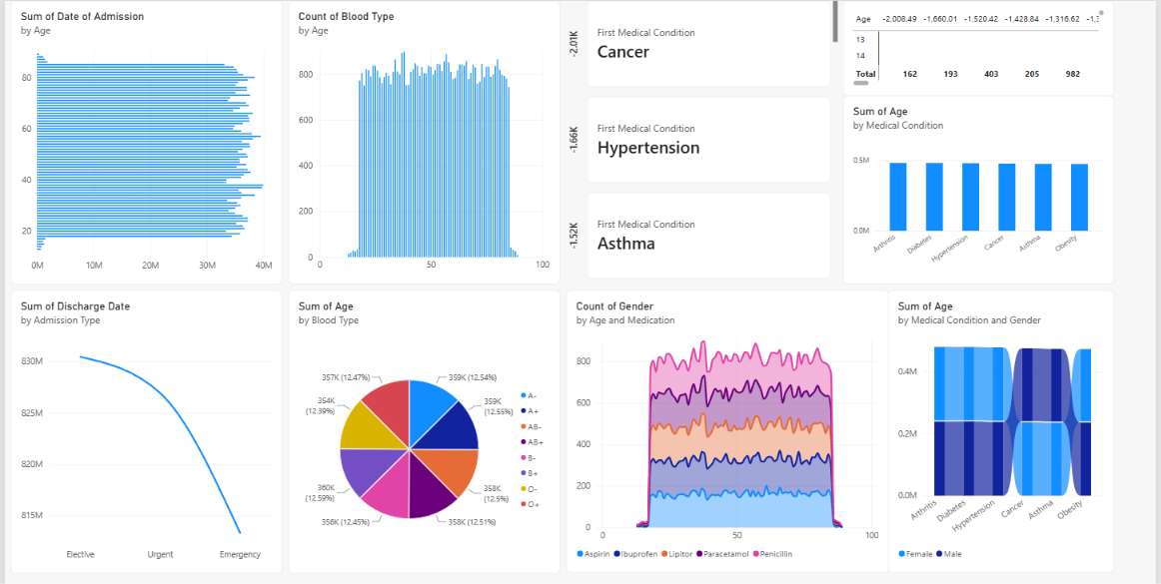
Tableau
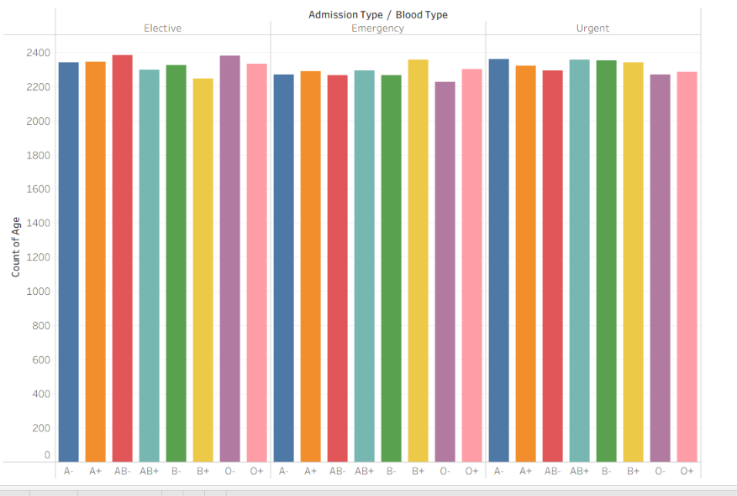
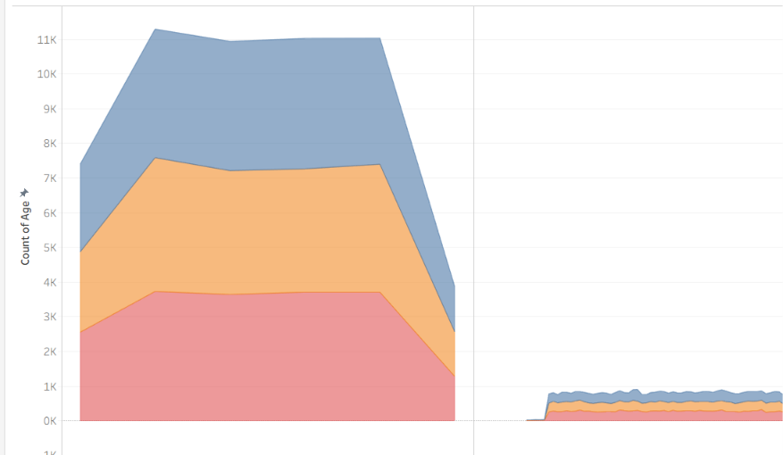
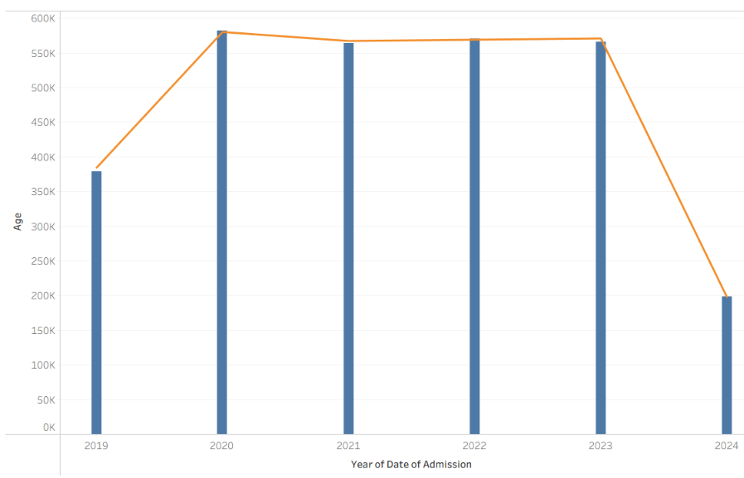

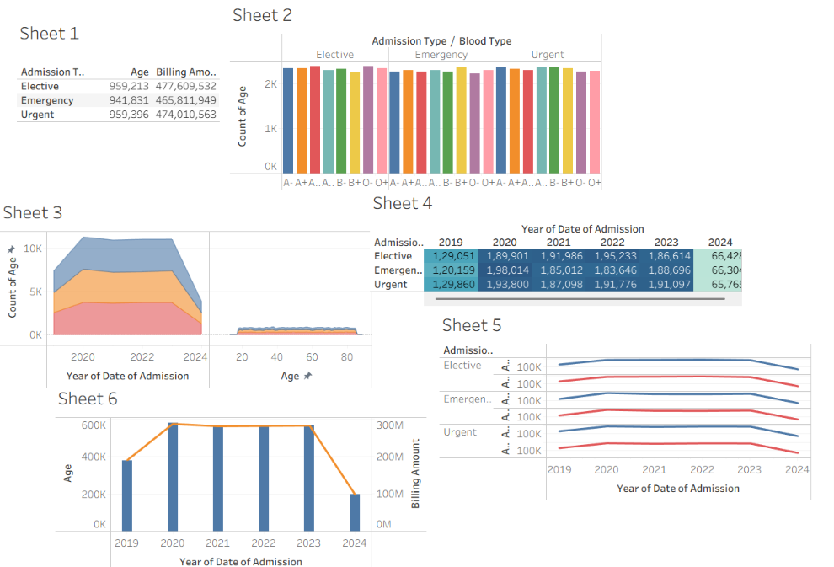

Result:
Thus the data visualization was successfully completed in jupyter,Power BI,Tabelu

